**Grade 12 PAT**

**Project Design Document**

**Jean De La Paix Kwizera Katabarwa**

**Student Register**

**Content**

**Cover page**

**Content page**

**Login screen**

**New account screen**

**Login/Register Help screen**

**One time Register screen**

**Student attendance History interface**

**Daily register interface**

**Analysis interface**

**Late Students**

**Absentees**

**Registering help**

**Secondary storage design**

**How are classes linked**

**USER INTERFACE DESIGN**

**Login screen**

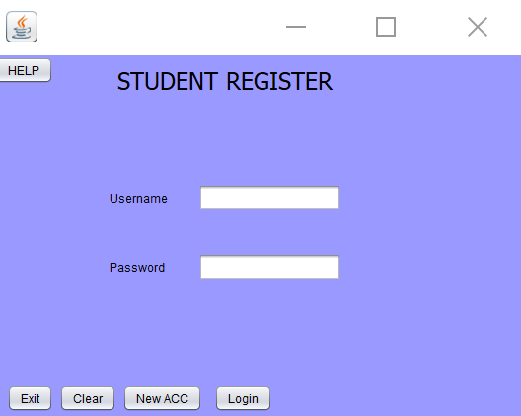

|  |  |
| --- | --- |
| **Description** | **This is the first screen that pops up when you start the application. It allows the user to exit via the Exit button, clear the textfields via the Clear button, create a new account via the NewACC button, login via the Login button.** |
| **Data** | **The user’s login details** |
| **Actions** | **Login**   * **It runs through the text file checking whether the Username and Password correspond with data in the text file. If the input matches and is correct, the login screen will proceed to the next screen. If the input does not match the suitable error will be displayed.**   **NewAcc**   * **It runs through the text file checking if the user’s new details do not match any of the other user’s details. If the user’s details don’t match then the users details are added to the text file and then the user may login and proceed to the next screen. If it does match a suitable error message will be displayed to the user in a message dialog box.**   **Help**   * **This displays all the helpful information. It is displayed at the same time as the login screen.**   **Exit**   * **It exits the whole application**   **Clear**   * **It clears all the information in the text fields** |

**New account screen**

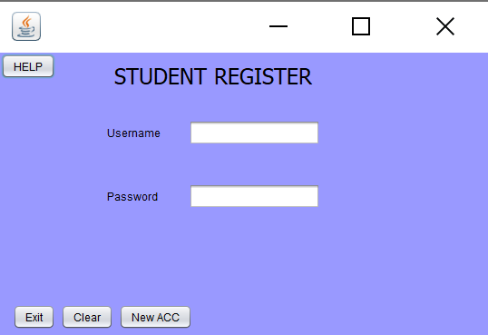

|  |  |
| --- | --- |
| **Description** | **This is the first screen that pops up when you start the application. It allows the user to exit via the Exit button, clear the textfields via the Clear button, create a new account via the NewACC button, login via the Login button.** |
| **Data** | **The user’s login details** |
| **Actions** | **Login**   * **It runs through the text file checking whether the Username and Password correspond with data in the text file. If the input matches and is correct , the login screen will proceed to the next screen. If the input does not match the suitable error will be displayed.**   **NewAcc**   * **It runs through the text file checking if the user’s new details do not match any of the other user’s details. If the user’s details don’t match then the users details are added to the text file and then the user may login and proceed to the next screen. If it does match a suitable error message will be displayed to the user in a message dialog box.**   **Help**   * **This displays all the helpful information. It is displayed at the same time as the login screen.**   **Exit**   * **It exits the whole application**   **Clear**   * **It clears all the information in the text fields** |

**Login/Register Help screen**

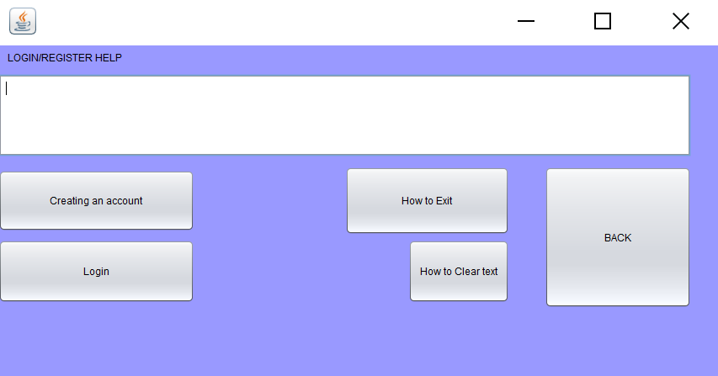

|  |  |
| --- | --- |
| **description** | **This is the screen that will pop up upon the click of the help button.** |
| **Data** | **The users selection of a help topic is used to display a message in the text area** |
| **Actions** | * **Creating an account**   **Message displayed**  **“ Write your name, password and the grade being registered then press NewACC to create a new account”**   * **How to exit**   **Message displayed**  **“ Press the Exit button to exit the app”**   * **Login**   **Message displayed**  **“wrie your user name then password then press Login"**   * **How to clear text**   **Message displayed**  **“Press the Clear button to remove the written Name, Password and Grade ”** |

**One time Register screen**

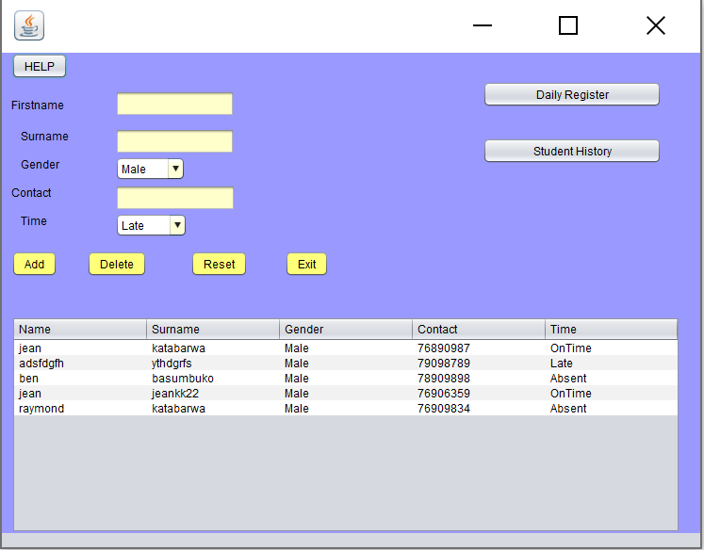

|  |  |
| --- | --- |
| **Description** | **This is the screen that pops up after the user has successfully logged in via the login screen. It allows the user to add data delete data reset the text fields and exit the register. This is used to register students only for the first day of them being marked in this app. After that students will be marked daily in the daily register.** |
| **Data** | **Student details** |
| **Actions** | **Add button**  **It allows you to add or register a student**  **Delete button**  **This allows you to delete a record**  **Reset**  **This allows you to clear every input in the Firstname, Surname and contact TextBoxes.**  **Exit button allows you to exit the application** |

**Student attendance History interface**

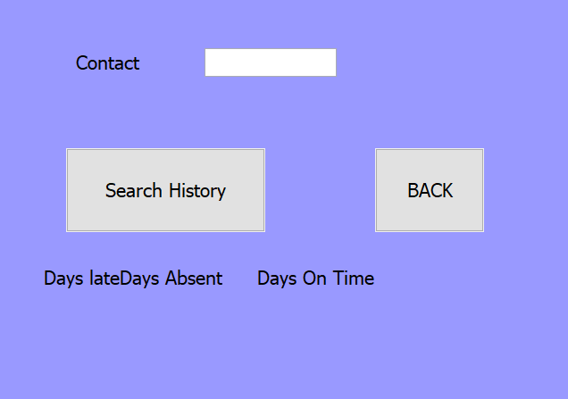

|  |  |
| --- | --- |
| **description** | **This is the screen that will pop up upon the click of the Student History in the register screen.** |
| **Data** | **Total number of student’s days absent, on time and late record** |
| **Actions** | **Student’s contact number is written Search History button is clicked**  **Three label below Days Late,Days Absent and Days On Time will display the total days for the respective time** |

**Daily register interface**

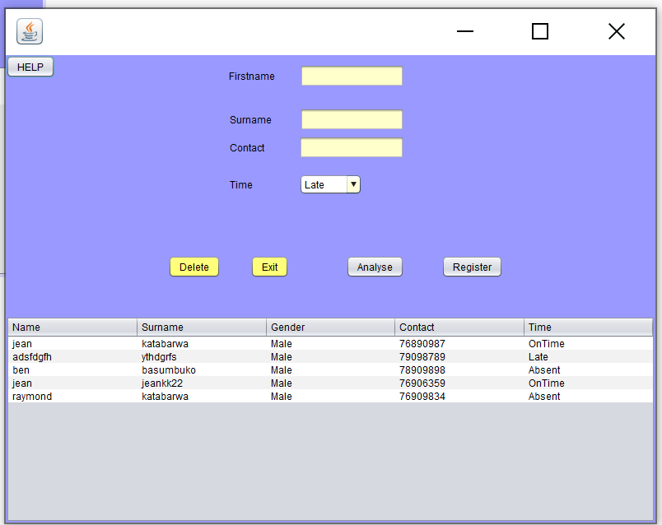

|  |  |
| --- | --- |
| **Description** | **This is the screen that pops up when the user presses daily register in the One the time Register screen.** |
| **Data** | **Students’ daily attendance details** |
| **Actions** | **The user clicks on a student’s row.( the student’s data is shown in the text boxes)**  **Then the user choses what time the student arrived**  **Register**  **This updates the table’s student arrival time**  **Delete button**  **This allows you to delete a record**  **Reset**  **This allows you to clear every input in the Firstname, Surname and contact TextBoxes.**  **Exit button allows you to exit the application** |

**Analysis interface**

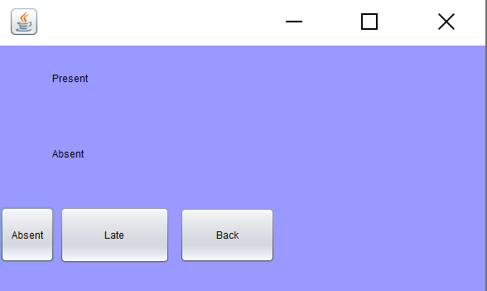

|  |  |
| --- | --- |
| **description** | **This is the screen that will pop up upon the click of the Analysis in the Daily register Interface.**  **Automatically the total number of students Present (those who came on time and those who came late) and Absent students will be shown** |
| **Data** | **No data from the user is taken in but data is shown for Present and absent students** |
| **Actions** | **When the absent button is clicked a table of students absent will be shown when the late button is clicked the table of students who came late will be shown and when the back button is clicked the user will be taken back to the daily register interface.** |

**Late Students**

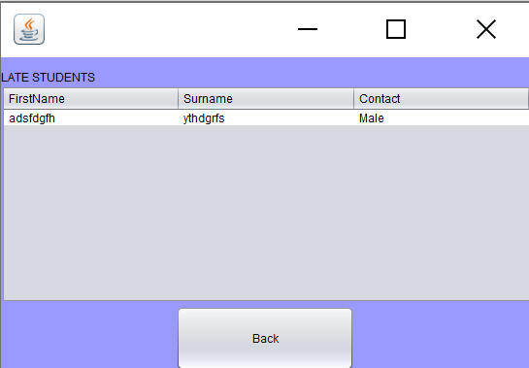

|  |  |
| --- | --- |
| **description** | **This is the screen that pops up when you press the Late button** |
| **Data** | **The students that came late** |
| **Actions** | **Fetches data from the Student Register Database and displays it in this table**  **The user can only Press the Back button from this screen to go back to the Analysis screen** |

**Absentees**

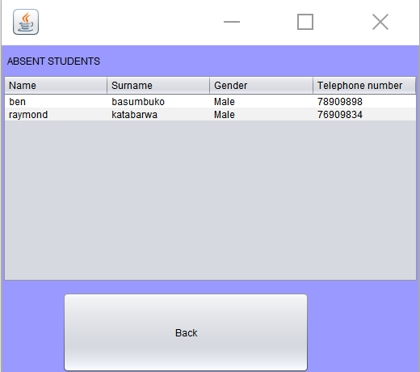

|  |  |
| --- | --- |
| **description** | **This is the screen that pops up when you press the Absent button** |
| **Data** | **The students that are absent** |
| **Actions** | **Fetches data from the Student Register Database and displays it in this table**  **The user can only Press the Back button from this screen to go back to the analysis screen** |

**Select all students from table students where time= absent**

**Display in table**

**Registering help**

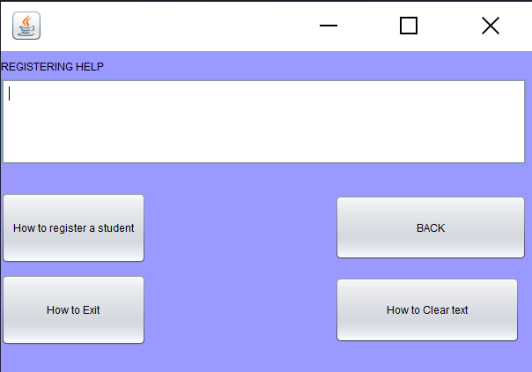

|  |  |
| --- | --- |
| **description** | **This is the screen that will pop up upon the click of the help button in the daily register or one time register.** |
| **Data** | **The users selection of a help topic is used to display a message in the text area** |
| **Actions** | * **How to register a student**   **Message displayed**  **“Write the First Name, Surname, Gender, Contact number and Arrival time then press add”**   * **How to exit**   **Message displayed**  **“Press the Exit button to exit the app”**   * **How to clear text**   **Message displayed**  **“Press the Clear button to remove the written Name, Password and Grade"** |

**Sequencing and algorithms**

**The login screen is displayed**



**Start**

**Select all from Users database table**

**User=[getName,getPassword]**

**jTextFieldUsername**←input

**jPasswordField1**←input

if **jTextFieldUsername isEmpty and jPasswordField1 isEmpty then print Username and Password required**

**end if**

**else**

**found**←false

**posInList**←0

for

i←0

i<users size

increment i

**if**

**jTextFieldUsername =User position i**

**found=true**

**posinList=1**

**end if**

**end for**

**if**

**found= false**

**print “invalid login”**

**end if**

**else**

**found = true and users positioninList = databasePAssword**

**closeLogin**

**open User interface**

**end if**

**else**

**print “Invalid login, please enter the correct credentials”**

**clear form**

**end else**

**New Account**



**User name and surname are typed and the user clicks New Acc**

**Insert into users table in the StudentRegister database values Username and Password**

**Close this screen and open the Login screen**

**Help screen**

**Login Help**



**If creating an account clicked**

**Display "Write your name,password and the grade being registered then press NewACC to create a new account" in text area**

**If Login clicked**

**Display "wrie your user name then password then press Login" in text area**

**If How to exit clicked**

**Display "** **Press the Exit button to exit the app" in text area**

**If how to clear text clicked**

**Display “Press the Clear button to remove the written Name, Password and Grade” in text area**

**Main Menu**

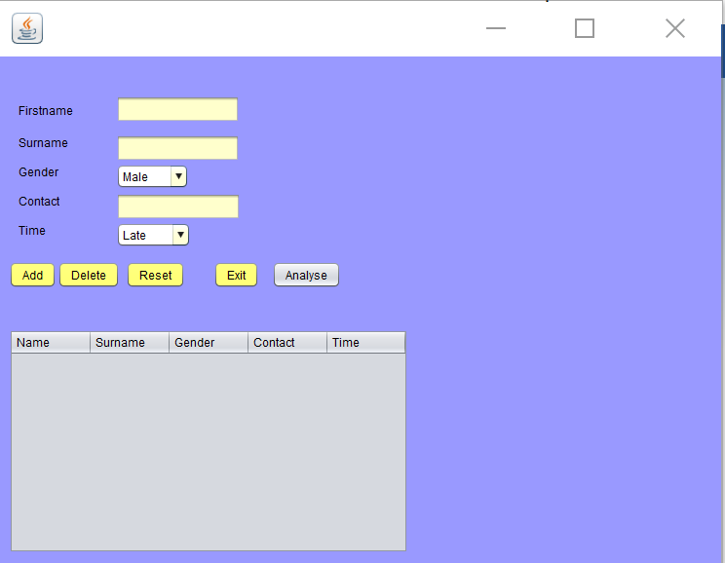

**The user types in First name, Surname choses male or female, types the contact number and the arrival time of the person being registered.**

* **The user clicks on “Add” button**

1. **If Surname is empty display error message**

**If Surname is empty display error message**

**If Contact is empty display error message**

**Contact←contact text**

**If Contact length< 8 display error message will be displayed**

**If Contact not integer an exception will be thrown**

**If contact first 2 numbers not 76 or 78 or 79 display error message**

1. **Data inserted will be retrieved and displayed in a Studentregister database table students.**

**Students table has firstname, Surname,Gender,Contact,Time columns**

**Firstname← firstname text**

**Surname←surname text**

**Gender←gender chosen item**

**Contact←contact text**

**Time columns←time chosen item**

1. **Data inserted will be retrieved and displayed in a Studentregister database table students.**

**Students table has firstname, Surname,Gender,Contact,Time columns**

**Firstname← firstname text**

**Surname←surname text**

**Gender←gender chosen item**

**Contact←contact text**

**Time columns←time chosen item**

1. **Create Arraylist of type students**

**query = select all from Students**

**attendance← Studentregister**

**While query has next line**

**Stdnt = Student CellNumber,surname,Gender,Contact,TimeTokenise**

* **When delete button is clicked**

1. **Display confirm dialog box ”Are you sure you want to exit Student register?”**

**if Yes option is clicked Exit**

**if NO option is clicked cancel**

* **When reset button is clicked**

1. **Set firstname text to null**

**Set surname textfield to null**

**Set contact textfield to null**

**Set firstname error message to null**

**Set surname error message to null**

**Set contact error message to null**

* **When exit button is clicked**

1. **Display confirm dialog box ”Are you sure you want to exit Student register?”**

**if Yes option is clicked Exit**

**if NO option is clicked cancel**

**Absent Students**

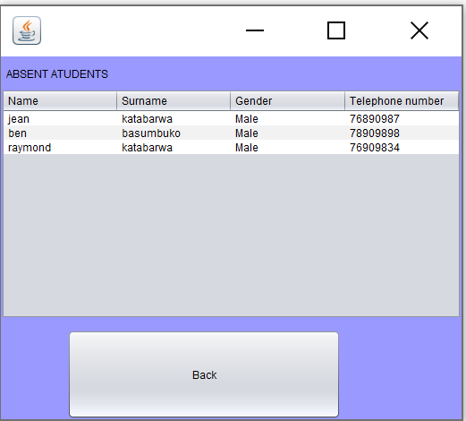

**Select all students from table students where time= absent**

**Display students in table**

**Late students**



**Select all students from table students where time= Late**

**Display students in table**

**Login Help**



**If How to register a student clicked**

**Display “Write the First Name, Surname, Gender, Contact number and Arrival time then press add”in text area**

**If how to exit clicked**

**Display “Press the Exit button to exit the app”in text area**

**If BACK clicked**

**Display “Press the Exit button to exit the app”**

**in text area**

**If how to clear text clicked**

**Display “Press the Clear button to remove the written Name, Password and Grade"**

**in text area**

Student History



**ContactNumber←input**

**Late ←0**

**OnTime ←0**

**Absent ←0**

**timesLate ←ContactNumber Late**

**timesEarly ←ContactNumber Early**

**timesAbsent ←ContactNumber Absent**

**scanner←StudentDatatxt**

**S:String**

**while scanner has next line**

**S=scanner next line**

**if s=timesLate**

**Late++;**

**End if**

**if s=timesEarly**

**OnTime++;**

**End if**

**if s=timesAbsent**

**Absent++**

**End while**

**Display late**

**Display OnTime**

**Display Absent**

**Daily register interface**

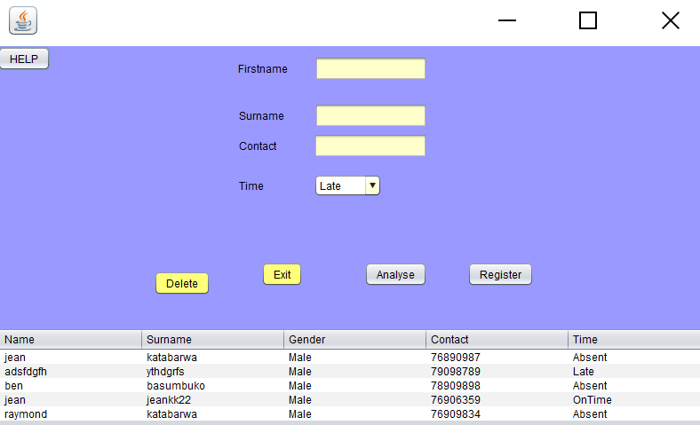

**Then a record is clicked**

**First nametext←table Name**

**Surnametext ← table surname**

**Contacttext ← table contact**

**time← table time**

**register button clicked**

**update student table where contact = Contacttext**

**create text file StudentData**

**write contact+ Time**

**Create textfile ArrivalT**

**Write contact+time+CurrentDate**

**Annalise clicked**

**open analysis screen**

**Exit clicked**

**exit the program**

**if delete clicked delete row from students where contact = contactText**

Explanation of Secondary Storage Design

Both databases and Text files will be used. databases will be used to store the primary key and the text file will be used to store multiple values with that same primary key. The text file is use full in this case because if the database was used to store the text file data it would cause data redundancy

**Secondary storage design**

**Users(teachers)**

**This is where data will be stored when creating a new account**

**This is where login data will be fetched from when logging in**

**A class called Users will be used to retrieve data in this table.**

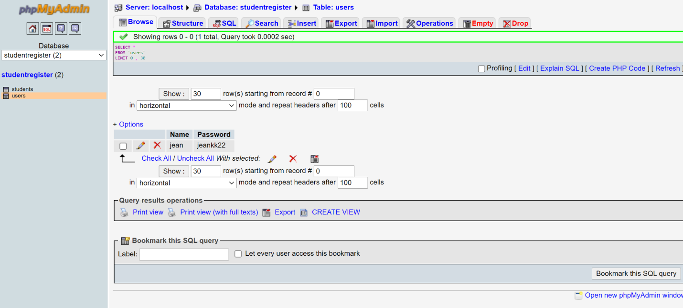

**Students**

**This is where data will be stored when adding a student in the One Time register screen**

**A class called Student Register will be used to retrieve the name surname gender contact and time details in this table.**

**This is the data that will be updated when marking daily attendance**

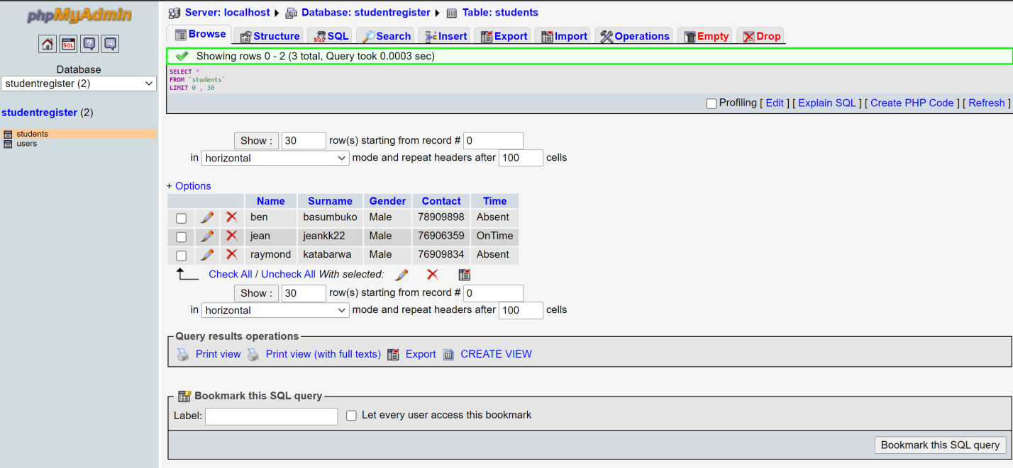

**Student History**

**This is the student history storage in a text file. Every day when a student is marked OnTime,Late or absent their data will be captured and stored in the StudentData text file in this format:**

**Name Surname Time**

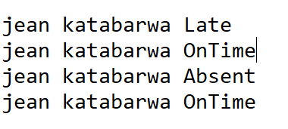

**Class diagrams and how they are linked**

